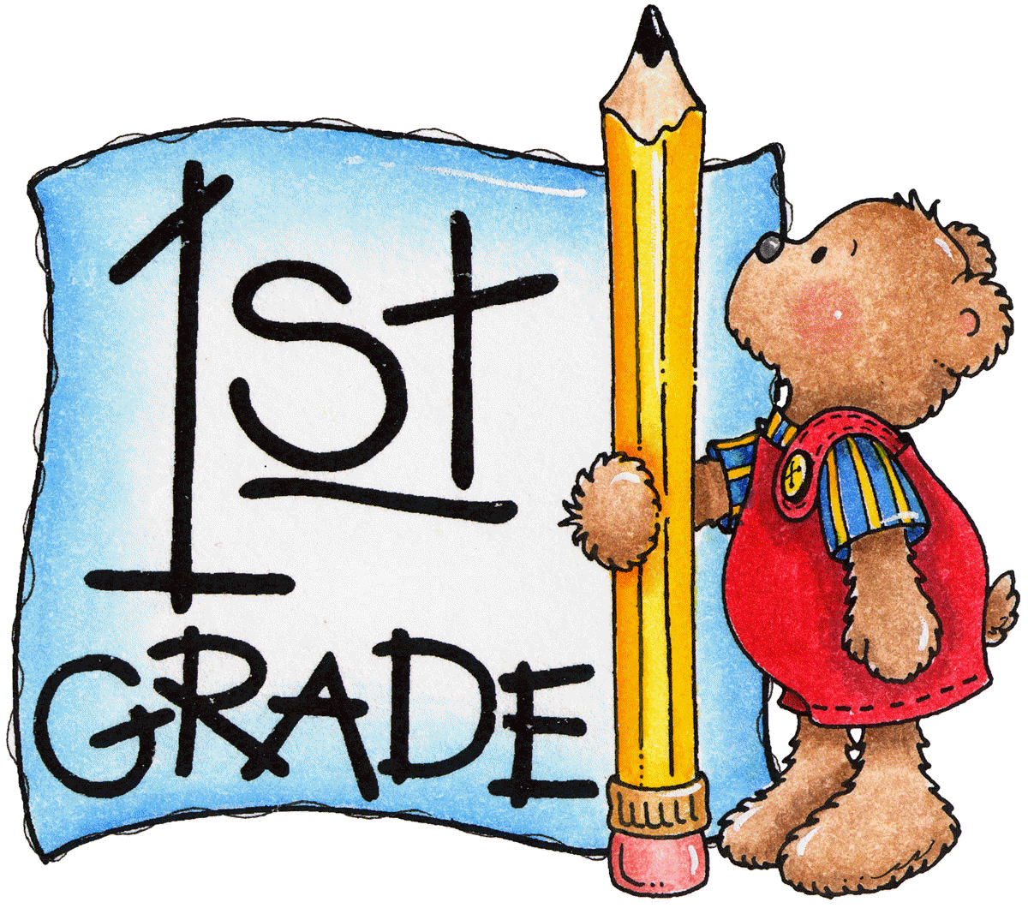

- Internet access
- Computer, IPad, Tablet, Cell phone
- Headphones
- Pencils
- 4-6 Spiral notebook folders (To organize class subjects; math, reading/writing, science and social studies)
- Whiteboard (8.5x11)
- Dry erase markers
- Colored pencils, crayons/markers
- Ruler
- Eraser
- Safety scissors
- Glue sticks
- Lined Paper, printer paper, construction paper
- Comfy chair and footstool
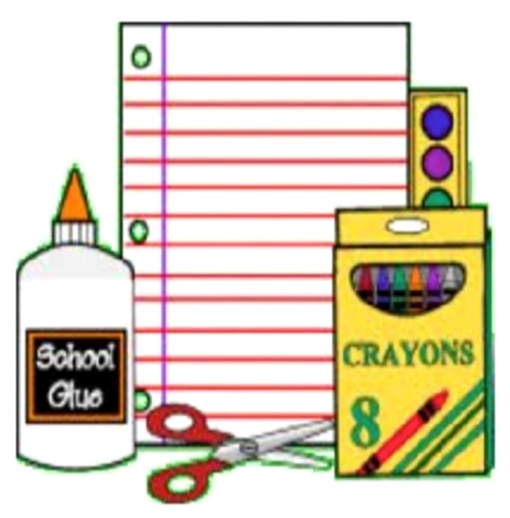
- Small desk/table for device

